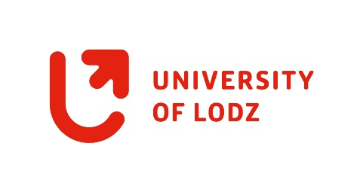

Confirmation of
Participation
This is to confirm the participation in the UNIC Format (Course, CityLabs, etc.) “Title” organised by Name, University, in cooperation with Name, University. The Format was held on DATE/from DATE to DATE.

To:
«name_student» «surname_student»
«home_university_of_student»

Description of the format: Lorem ipsum dolor sit amet, consectetuer adipiscing elit, sed diam nonummy nibh: Lorem ipsum dolor sit amet, consectetuer adipiscing elit, sed diam nonummy nibh euismod tincidunt ut laoreet dolore magna aliquam erat volutpat. Ut wisi enim ad minim veniam, quis nostrud exerci tation ullamcorper suscipit lobortis nisl ut (possibly Workload)

Date Signature

